Rolling window approach

**Model**

**TCI 1 = estimates from the vars package**

**TCI 2 and 3 = estimates from the Connectedness Approach package**

* All model runs are for VAR (1)
* Forecast horizon = 10
* I tested this from 1-10 and there was little material impact
* The shortest series (WCA, 68 data points) has been removed

**Model testing – Window size 50 🡪 200 (25 week increments)**

Serial Correlation Test

* Using the Breusch-Godfrey Test

* Also sit from 0.11-0.21
  + The lowest being for the rolling window set to 100 weeks (0.11)
  + The highest being for the rolling window at 175

Therefore, increasing window length does not improve the model for this measure

Using the ES test, the results are slightly better

Normality Test

* Using the Multivariate Jacque bera test
* Fails for every model estimation across all window sizes – proportion of model runs where p-value < 0.05 = 1
* Q: Does this matter?
  + Is it reasonable to expect an 8 variable distribution to be approximately normal?

**Problem**

* Increasing window size provides no improvement for the model at all – the lowest occurs for rolling window 50 (proportion at 0.94)

**Model testing – h (1,10,15)**

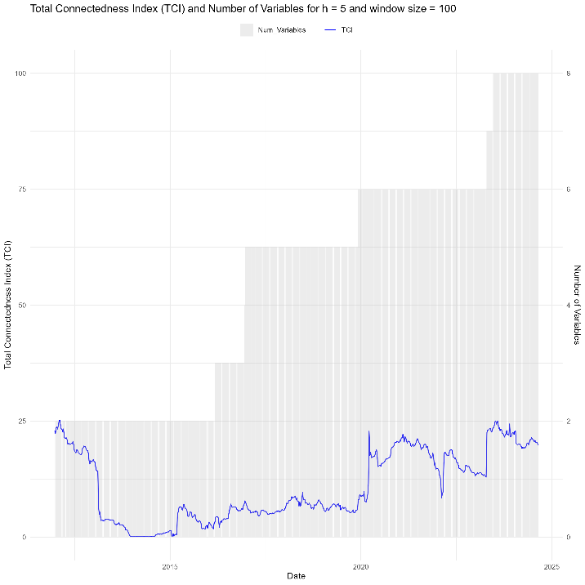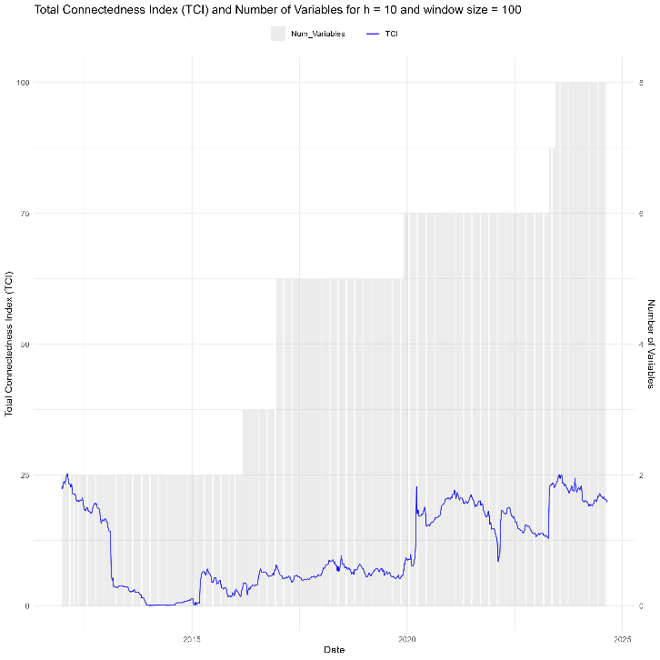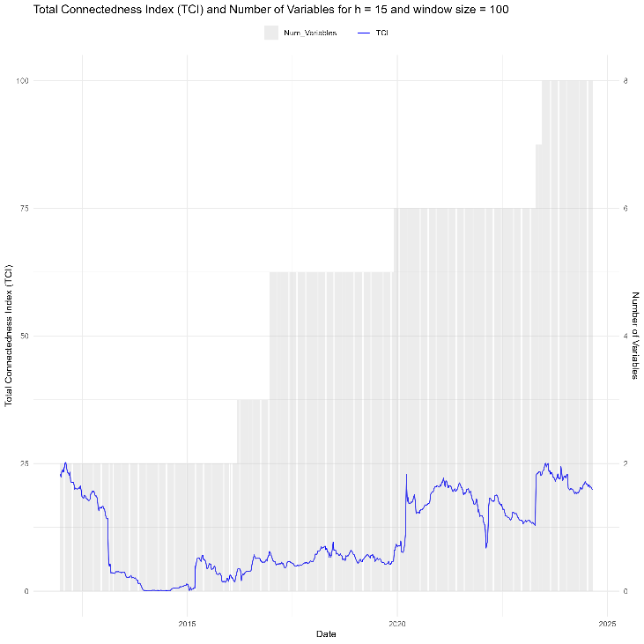

**Questions**:

1. Problem moving from weekly returns / volatility to daily returns?
   1. Gives more data points for the rolling window analysis, but more volatile?

**Estimation**

Optimal settings

WCA removed

Window size = 100

H =10

|  |  |  |
| --- | --- | --- |
| Method | Proportion_Serial_Failed | Proportion_Normality_Failed |
| Method2 | 0.1138 | 1.0000 |

